Hi,

As per your profile review, we think that you might be a good fit for our job post.

Before going into the further interview rounds, we would like to know the answer to these questions. Please answer them to the best of your knowledge so we can schedule your next interview rounds as early as possible.

1. Why do you want to join as a BD Intern?
I am willing to join as BD intern because I am eager to work in this sector. Therefore, the internship will be ideal for me. This company, its aims, and my abilities, I am confident I can provide all you need in a candidate.

2. We have plans to promote our BD Intern as a full-time Business Development Executive. Would you be able to continue working as a Business Development Executive after completion of your internship?
Yes, I would be able to continue working as a Business Development Executive after the completion of my internship.
3. Are you okay to work in our defined stipend range 3k to 20k per month?
Yes, I am okay to work in your defined stipend range.
4. How many hours you can work daily?
I can work like 7 to 8 hours daily.
5. Do you have any experience in generating any kind of business? If yes, please describe how did you use to generate new businesses/leads/clients such as; through calling, sending emails, meeting personally, or how?
Yes, I have experience in generating leads through calling, sending mails and other online methods.
6. Do you have experience in generating businesses through bid submission? If yes, please mention which portals you have used.
No, I don’t have any experience in generating businesses through bid submission.
7. Have you done business development through social media channels networking such as through LinkedIn or Facebook connections and groups? If yes, explain briefly what exactly you did.
Yes, the process we used included LinkedIn and other online sources for generating leads and converting them into sales for our organization.
8. Can you write grammatically correct ads, scripts for marketing that will trigger the actions of clients/customers? If yes, what would be your strategy for writing these ads?
Yes, I can write grammatically correct ads, scripts for marketing that will trigger the actions of customers. I would first consider using some catchy words and sentences that attract clients and compel them to at least take a call with us to know more about it.
9. What is your highest educational qualification? Mention the stream you've studied in.
I have completed my higher secondary (XII) and currently pursuing BCA (Bachelor’s in Computer Applications) from Manipal University.
10. How much was your last drawn salary?
14,000/- per month. For work from home profile.
11. Do you have proof of your salary getting credited in your bank account such as your monthly bank statements which can prove the amount getting credited from the company’s account? [We accept only bank statements either in PDF format or screenshots/pictures, cash receipts or salary slips will not be approved as proof of salary. If you don't have proper proof then mention it before, else in the case of failure in providing the salary and experience proof, we will cancel the joining post-selection also.]
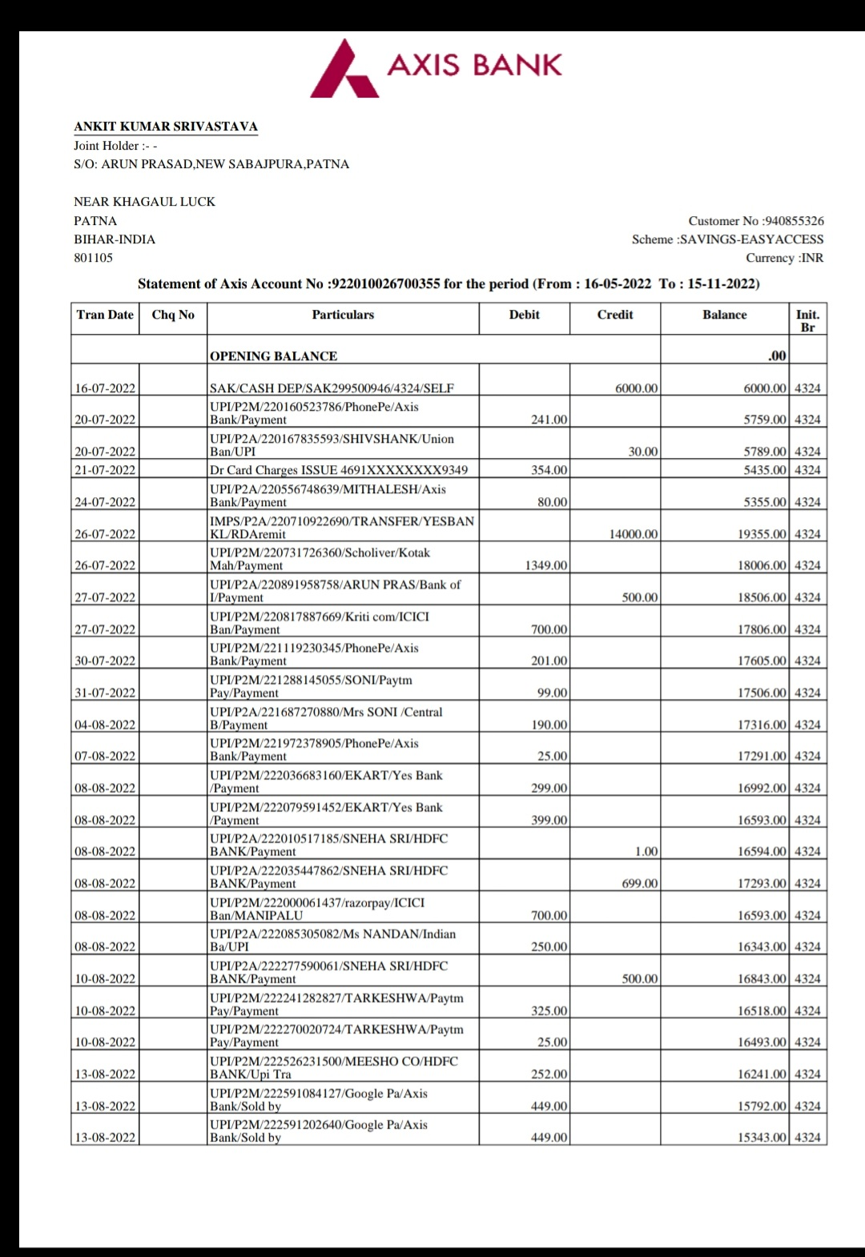
12. Why are you willing to leave your current organization?
I am looking for new challenges and new opportunities in these field.
13. Which city/state do you live in? It is work from home position now but would you be able to relocate to Delhi/NCR in the future?
I am live in Patna, Bihar currently. Yes, I will be able to relocate to Delhi/NCR in the future.
14. If selected, how soon can you join us?
I can join immediately.
15. Can you work on the night shift (US Business Hours)?
Yes, I can work on the night shift.
Thanks

